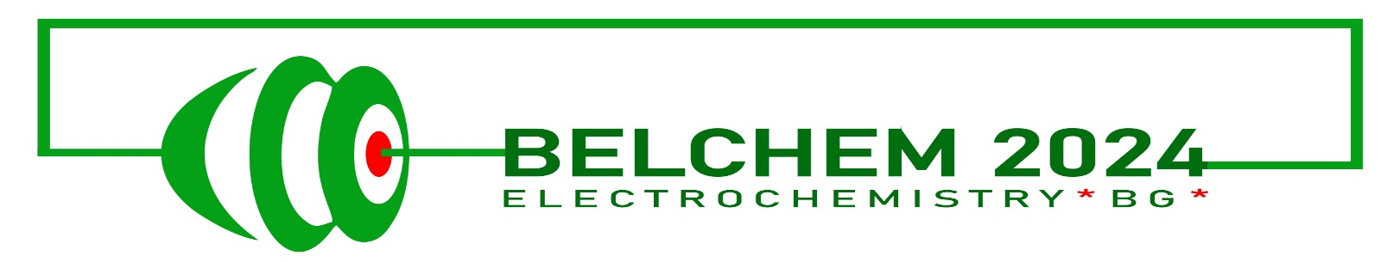 | BELCHEM 2024  Electrochemistry for environmental protection, life quality improvement and sustainable energy  25-28 September, 2024  Park hotel „Europe“, Haskovo, Bulgaria  REGISTRATION FORM  First name:  Family name:  Institution:  e-mail:  Phone:  I will submit an abstract for (please indicate):  Oral presentation  Poster presentation  Authors of the presentation:  ………………………………………………………………………………………………………….  ……………………………………………………………………………………………………………  Title of the presentation …………………………………………………………………..  ……………………………………………………………………………………………………………  …………………………………………………………………………………………………………  …………………………………………………………………………………………………………  I need accommodation in:  Single room  Double room  Accompanying person if any:  Name:  Please, send the registration form to:  belchem2024@ipc.bas.bg  DEADLINE: 15.03.2024

